**Fieldwork Assignment – Doctor Who’s TARDIS Console Room**

When thinking about an interactive sound model based on a fictional scenario, my thoughts ran to one particular audio motif:

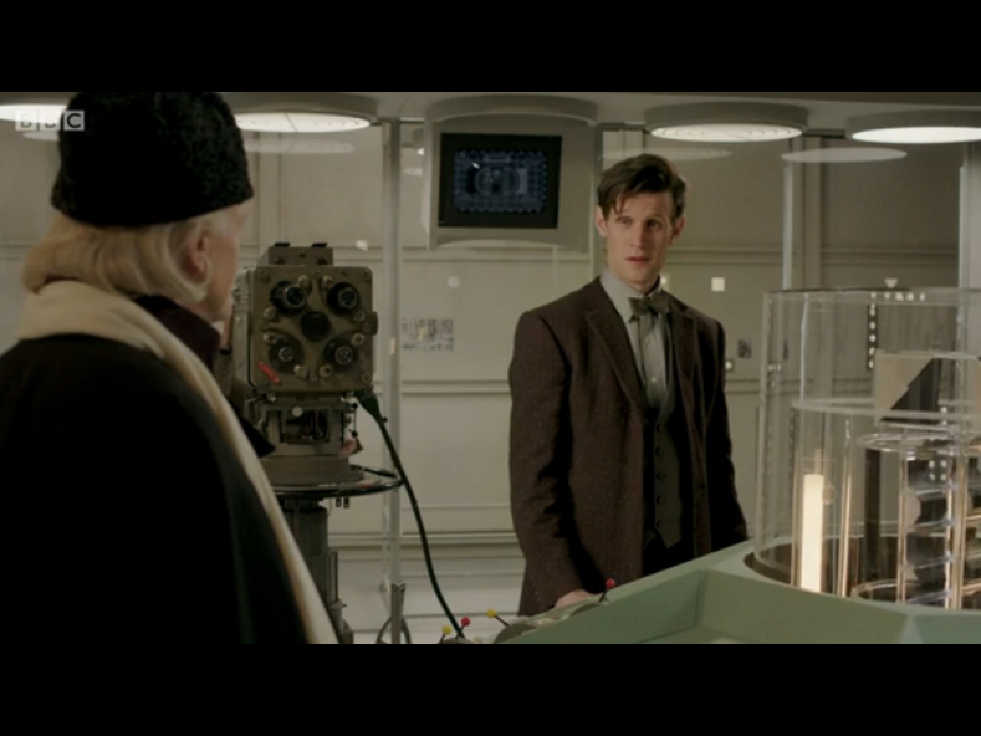What does this image communicate and why did it appeal to me? The fact that it does represent a lot, the depth of it, has inspired me. Just only last year Doctor Who surpassed its 50th anniversary, making it the longest running science fiction TV show in the whole world. This particular image is a scene from the BBC docu-drama “An Adventure in Space in Time”, which celebrates the milestone. The docu-drama reconstructs the story behind the inception of Doctor Who and this scene shows the First Doctor, William Hartnell (played by David Bradley) handing over the reigns to Patrick Troughton. The emotion of his leaving overwhelms Hartnell and as he looks over the first TARDIS console, he sees most recent Doctor, Matt Smith, who acknowledges Hartnell’s legacy as the First Doctor. This particular scene captures a lot of emotion, from old to new, from the First to the Twelth over a period of 50 years. Despite all the progressions, changes and advances throughout the years, one thing has not changed much at all, and so begins my attempt to sonify that particular sound environment.

Being one of the iconic and unique sounds of British history and a sound I grew up with during my early teenage years, the sound of Doctor Who’s TARDIS (Time And Relative Dimension In Space) originated back to the 9th of January 1965 in the episode “The Powerful Enemy” (part 1 of the “The Rescue”). William Hartnell’s incarnation of the Doctor describes the sound as “materializing” rather than the spaceship landing. This is the first time that the TARDIS had been given a sound effect and soon became one of its most famous characteristics, another being that it comes in the form of a police-calling box. Much like a car’s engine to notify the driver of its movement (increased revving to increase speed and vice versa), the TARDIS’s materialization sound signifies its appearing and disappearing. Being a big fan of the sound (and in extension, the TV show), combined with its unique origin, I was fully motivated and enthusiastic on creating some of the sounds from the show.

The sound of the materializing TARDIS was created by sound designer Brian Hodgson. The Liverpool born composer and sound technician joined the BBC Radiophonic Workshop in 1962 and worked with Delia Derbyshire, better known for creating the iconic Doctor Who theme tune. He also was one of the people behind the voices of the Daleks. So how was this brilliantly creative sound devised? Well to keep the story short and sweet, Hodgson took the back door key of his mother’s house and ran it along a bass string of an upright piano. He then used the tape reverse effect combined with white noise and reverberation.

The scenario of my sound model is based on the TARDIS space/time machine, but on a primitive level, what I would imagine my version of the first TARDIS console room could have sounded like. To gain a better understanding of what I implemented (along with spatial arrangement and purpose of each element), I have placed below an annotated diagram of what most TARDIS console rooms have in common (using the first console room):

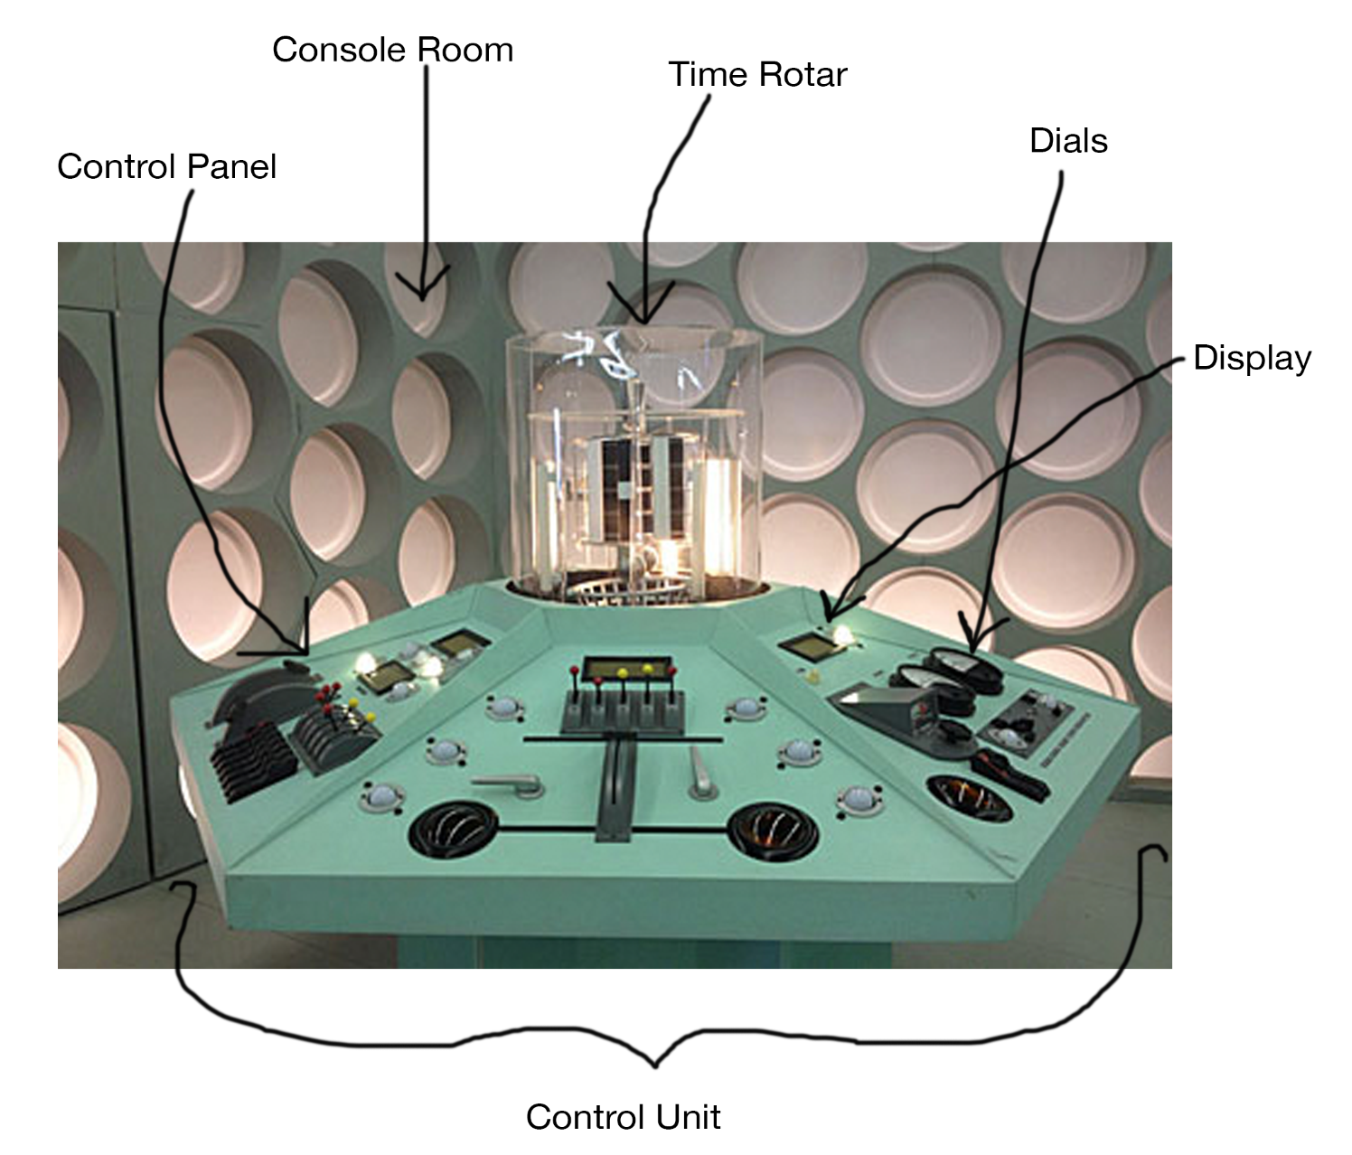

The scenario that I had devised is that of movement on a control level. Although the TV show makes it sound like all the audible elements are one, there are in fact quite a few sound elements that are combined together to create a symphony of machinery sounds (details of which will be described later on). The main different states of the TARDIS that I have implemented are as follows: materializing (landing), dematerializing (taking off), low speed cruising, medium speed cruising and engine struggling. Other smaller scenarios include control panel button presses, engine start/stop and time rotar. The diagram above was used as a basis on how the behavior of the machine is controlled and therefore how the sound model is controlled within PureData.

Automated/real-time parameters are used to allow a user to control several aspects of the sounds. Parameters are as follows (parameter name followed by purpose/function and the type of control):

* Console room size (reverberation, using a slider)
* Console room damping factor (reverberation, using a slider)
* Console room depth (using wet/dry ratio, reverberation, using a slider)
* Engine struggle variance (providing toggle for engine struggle is switched on, enables changing ring modulation on a frequency basis, slider)
* Engine start/stop sound (boom sound that is triggered on key press)
* Dematerializing (engine increasing power towards optimum power, triggered on key press)
* Materializing (engine decreasing power from optimum power, triggered on key press)
* Low cruise speed (changes frequency of oscillation, triggered on key press)
* Medium cruise speed (changes frequency of oscillation, triggered on key press)
* Control panel button press (randomized FM, triggered on key press)
* Engine struggle toggle (switches on/off ring modulation, triggered on key press)
* Time rotar excitation (engine activity, triggered on key press)

The sound model that I have created does cover quite a few aspects of the sound and provides plenty of control. However most controls are simple triggers, with very few parameters allowing more flexibility, less of an overall change of the final sound.

Below I will go into more depth about the different design aspects and processes I went through to get to the final model (“*TardisMainConsoleRoom.pd*”). A live performance can be heard in *“TARDIS-ConsoleRoom.wav”*.

From the beginning of the model I knew exactly what kind of sound I wanted to create. Initial ideas and tests were conducted by looking over motivational material and inspiration. This included doing some background research, which is when I came across an article that describes some Hodgson’s thought processes before creating the sound (Hayes and Barber, 2013). He describes the process as “quite difficult” as he did not know how to imagine the sound of a time machine. Any sound has a physics based influence. But the problem that he had faced was imagining the physics of a science fiction object. This also influenced my decision to try to create unnatural sounds based on the original sound. Hodgson also talked about his technical approach to creating the sound in a short podcast (*Sound of the TARDIS*, 2013). I had now gained an understanding of what type of sound I wanted to go for.

Now that I had sufficient contextual and historical information, I moved onto thinking about different schools of design. Taking the concrete school I learned that the key concept is applicable to this particular case. Unlike a car engine sound, the TARDIS has the distinct sound associated with the control room, in addition to its state (whether it is materializing or not for example). This one event that belongs to the one object which, in turn, has one particular sound, which has now become its audible signature. Car engines on the other hand are much different particularly due to the variety of cars that are available. Imagine a scenario where you pick any car at random. What determines the sound triggered by the movement of the car? Does it use a petrol/diesel engine or a electrical engine? Are the cylinders in the engine in a straight 6 or v8 configuration? Many of these characteristics allow for variety and therefore cannot be approached using one particular low hum and rattling symphony (I listened to *“V12(1994), V10(2004), V8(2011), V6 Turbo(2014).mp3”* car engine sounds to understand this better). For me this meant that I would have to take the linear approach as the TARDIS has one particular approach in terms of its mechanisms, even if it is a fictional element. It is because of radiophonic workshops, like the one of the BBC’s , that this school exists, particularly with tape manipulation. However linearity in a sound is not very efficient in an interactive application such as Pure Data. So here I placed a mental note in my head to say that perhaps I can make my sound/interaction unique by allowing some variance in the sound.

Moving onto the essentialist school, I found that it is incredibly difficult to physically model the sound in the fiction universe (more towards parallel universe as the plots are often set in our time and contextual facts but just a difference of time or space). However in the real world, these sounds were actually created using physical objects such as the key scraping on the piano string. An effect like this would be incredibly difficult to program in Pure Data but there are alternatives such as importing a sample and changing its features. This ties in with the physical approach of sound design, to really understand the mechanisms that omit these sounds can be a daunting task if you are trying to recreate fictional sounds that come from ambiguous fictional objects. The only physical aspect I was truly able to create a dynamic parameter for was the TARDIS engine in a struggling state (which will be discussed in more detail later on).

The behavioral school has taught me that hard physical modeling is not very appropriate to use to implement the sound of a TARDIS. It was now about taking existing sounds and trying to find similarities or likenesses in order to come close to a piece that may resemble. The power of human hearing has allowed us to use our sense of perception to find incredible detail when thinking about the different elements. For example if I were to take the TARDIS sounds (“*TARDISsounds.mp3*”), I could say there are distinct sounds that represent the sound taking off (the heavy bassy drum like boom). There are also signs that show the state with frequency and intensity of the materializing/ dematerializing states. There is an underlying bass frequency to convey the scale and complexity of the machine. This particular school led me to take the acoustic approaches, which I have detailed just now. Like the physical approach, these parameters would be dynamic but predefined so that the final output sound is directly related to the machine, and that “over parameterizing” can cause a transform in the sound that could change the relationship with the sound and the event.

The overall audio makes it sound like the machine is “wheezing, groaning”. The phenomenal school taught me that, like the behavioral school, thinking about the physicality of the sound can be overwhelming, and that it can be better to think about the sound in terms what it is trying to communicate. Again, increasing in frequency of a particular sound can be related to the TARDIS leaving for example. Sometimes it is best to take a step back from the intense, technical areas of sound and take a phenomenological approach to understand what kind of event should be imagined or re-experienced in order to associate a sound with it like so.

Before I set off to create the different elements I wanted in ‘my version’ of the TARDIS, I decided that it would be best to build from the ground up so that I would be able to focus on which sound elements would require different levels of detail. After brainstorming and listening to more audio clips, as well as watching key scenes that featured the console room (*The Snowmen*, 2012). After gaining more of the understanding with the elements of the TARDIS console room, I narrowed it down to these few sound elements (from the most background bottom layer up to the ‘surface level’ level of detail layer): TARDIS state, cruise control, engine start/stop, time rotar (refer to earlier annotated diagram) and control panel.

Firstly the TARDIS state, essentially uses a very low frequency which only changes if the state changes. Using triggers, a sine wave is fed through a multi tap delay system to provide the thrumming-like sound, using the acoustical analysis made previously. Using a line object allowed controlled fluctuations of the sound on key press. The cruise control was another frequency that was at a much higher state but was modulated based on amplitude, making it sound like the machine is pulsating, like in the TV show. When this frequency is fixed, the amplitude modulation makes it sound like the TARDIS is at a resting stage. Combined with pink noise, the sound is given more depth. Together these two components come together to bring the materialization engine abstraction, with effectively does employ some physical structuring to my sound by separating different sounds and abstractions to create a compartmental system.

The engine start/stop sound is effectively, as I had mentioned during the analytical approaches stage, sounds like a very low bass drum. I found a sample online that had a base drum strike in it but the issue with it was that it was not low enough of a frequency. I then created the pitch shifting abstractions which accounts for this equation:

FreqOut = FreqIn * (1-phasorFreq *(delayPeriod)/1000ms)

Passing in the sound out of phase and then multiplying a phasor allowed a smooth pitch shift, which was used to turn down the frequency of the sample.

For the time rotar, I took the physical approach that Hodgson had taken many years ago when he devised the sound. But this time I added my own creativity. On a basic level the mechanism involved is very much like that of a slip stick implementation. So I decided to record a sound of a jar and coin scraping on a table. The physicality of the table allowed the noises to have some depth. The pitch shifting was also applied to these elements in order to get them at the right frequency. Ring modulation was used to allow the implementation of the engine struggling. Ring modulation involves multiplying two signals together and based the output based on the sum and differences of these signals, producing very metallic, unnatural and electronic-esque sounds. By feeding back these sine wave oscillators, the results were unpredictable but controllable to a certain extent by allowing the user to contro the frequency at which the modulation was occurring. Ring modulation is a combination frequency and amplitude modulation, which provided with very wobbly, sci-fi like sounds. This technique is famous as it was used to create the voices of the Cybermen and the Daleks aliens from Doctor Who. Using triggers, this effect was turned on and off.

The control panel sounds were generated using very basic frequency modulation synthesis. By randomizing the carrier frequency, modulating frequency and the depth of the modulation (creating the vibrato effect), I was able to create sounds that are uncanny in the sci-fi world such as the “beeps” and “boops” of Star Wars droid, R2D2. This was achievable by taking the phenomenological approach.

Finally to control the ambience of the sounds, I created an abstraction that dealt with reverberation. By using reverberation, there is the presence of accurate sound reproduction within a controlled environment, stepping away from the synthetic texture of the sound. I made the patch neat and easy to use by adding the reverberation object ([freeverb~]) in an abstraction. Parameters that were added to stimulate the environment were the size (scale of the console room), the damping (the sound absorption inside the room) and wet/dry ratio (the objects in the TARDIS, such as people or components). Together these formed the environment characteristics.

To conclude, I felt that the patch that I had created does a sufficient job at allowing me to recreate the sounds of a TARDIS in my own unique way. However there are elements to the project did not work so well. Although I mainly used the acoustical approach to recreate the sounds, I still felt that the sounds were very synthetic sounding, because it is mainly based of pure tones, that there was not much complexity or depth to the overall sound. To improve I could perhaps take more samples and manipulate them in a way to add more of an atmospheric feel to the scenario. Another thing that did not work as well as I had hoped was the sound of the time rotar, although it does follow a similar process that Hodgson had used. However I feel that there is one aspect in particular that should be improved, the dynamisms of the parameters. Out of the 12 parameters available, only one is can be changed dynamically, which is the sound of the engine struggling. Whilst using the system for myself, I realized that providing the user with much more control of the sound provides much more fluidity for the user, especially if it were to be used by a sound designer.

**References:**

BBC. 2014. *Doctor Who - Sound of the Tardis*. [podcast] 23 November 2013. Available at: http://www.bbc.co.uk/news/uk-england-norfolk-25056945 [Accessed: 27 Mar 2014].

*Doctor Who - The Snowmen.* 2012. [TV programme] BBC, channel 101, 25 December 2012.

Doctor Who Answers. 2014. *What Sound does the TARDIS make when lifting off*. [online] Available at: http://drwho.answers.wikia.com/wiki/What_Sound_does_the_TARDIS_make_when_lifting_off [Accessed: 27 Mar 2014].

Hayes, P. and Barber, M. 2013. *Doctor Who: How Norfolk man created Dalek and Tardis sounds*. [online] Available at: http://www.bbc.co.uk/news/uk-england-norfolk-25051061 [Accessed: 27 Mar 2014].